Hedera Related Work on Login-Server

Create Tables for managing needed data for hedera:
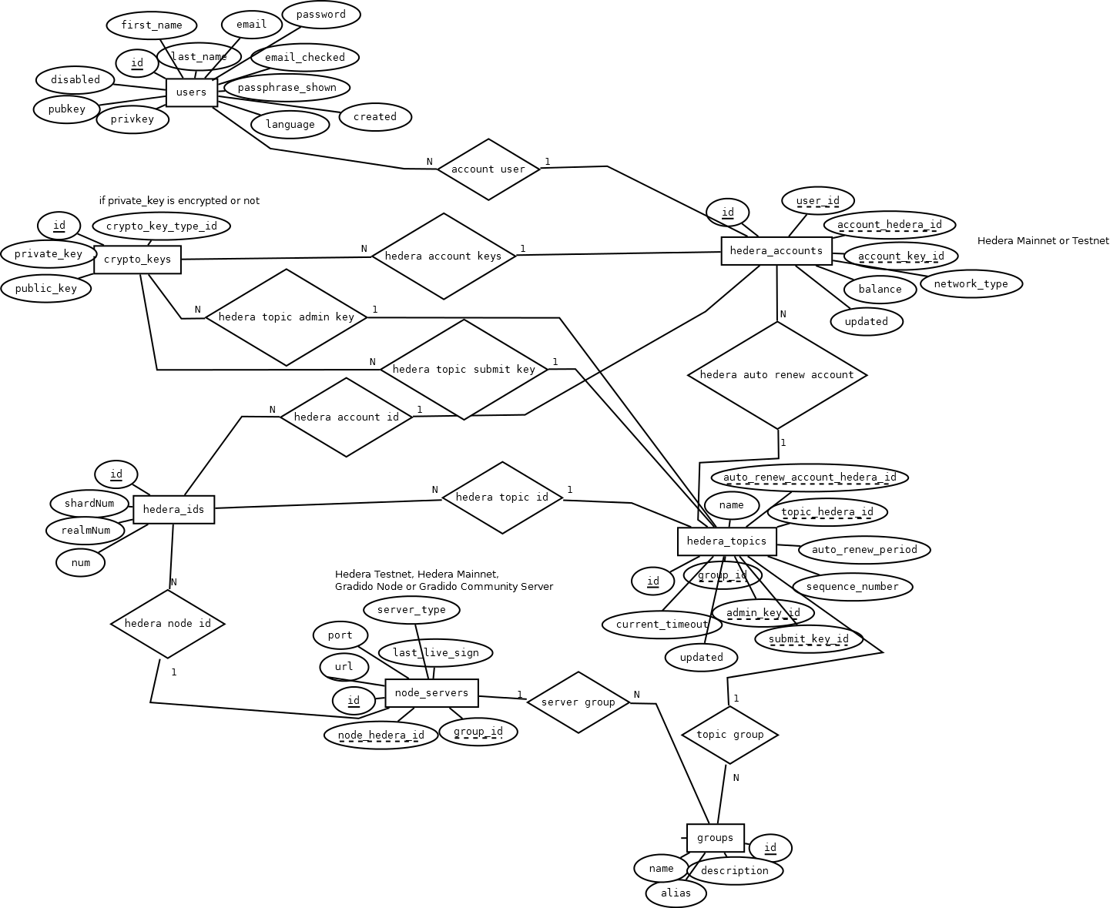

Write model, controller classes and pages for fill and change this data.
Write hedera wrapper classes to get filling and checking hedera proto messages better into Login-Server Workflow.


